





College of Arts Humanities and Social Sciences

Doctor of Psychology in Clinical Psychology (PsyD)

Will. Power.



Doctor of Psychology in Clinical Psychology (PsyD)
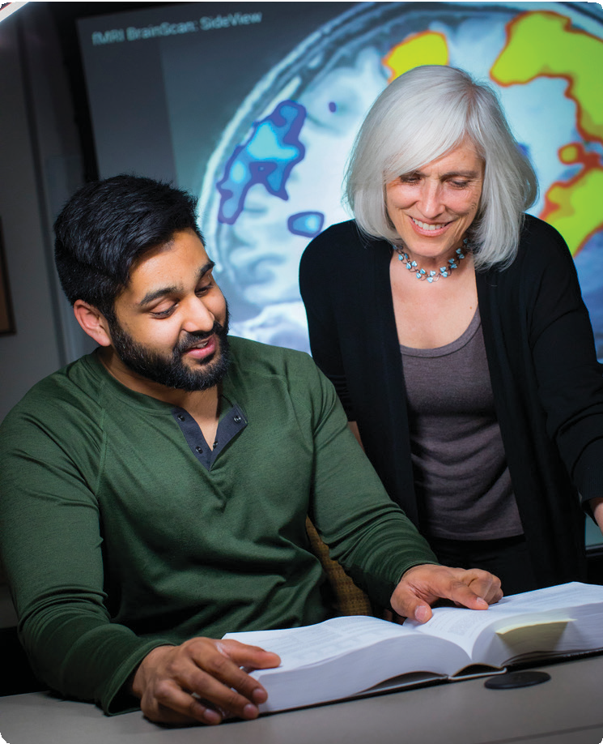
William Paterson University’s doctor of psychology (PsyD) program in clinical psychology is a practitioner-scholar oriented program. The PsyD program is a full-time, five-year training program that integrates academic coursework, supervised clinical training, and research experience at every stage of the student’s progress. A distinguished faculty of active scholars and practitioners leads the program.
Students may obtain a master’s in clinical and counseling psychology en route to the PsyD degree.
When you enroll in the PsyD program, you will study in a small community of peers and mentors.
Faculty who have diverse interests in both clinical practice and research will support your training in evidence-based assessment and intervention. The program offers individualized attention and state-of-the-art facilities in our Science Complex, which has teaching and research facilities, as well as a psychology clinical training suite featuring recording and monitoring capabilities. We also have a dedicated graduate student suite for work, study, and community.
The PsyD program in clinical psychology is fully accredited
by the American Psychological Association (APA), with an effective date of December, 2nd, 2021. The program was accredited for 10 years and the next accreditation site visit will be in 2031. For more information, please contact APA’s Office of Program Consultation and Accreditation, Commission on Accreditation or visit their website:

www.apa.org/ed/accreditation

Office of Program Consultation and Accreditation
American Psychological Association, Commission on Accreditation, 750 First Street, N.E., Washington, D.C. 20002-4242
Phone: 202.336.5979 Fax: 202.336.5978


Mission of the PsyD Program in Clinical Psychology
The mission of the William Paterson University PsyD program in clinical psychology is to prepare students to become competent and highly skilled psychologists in the delivery and evaluation of psychological services. Graduates are trained to critically evaluate research, contribute to psychological knowledge, and develop innovations in treatment and service delivery. The program is grounded in a practitioner-scholar model that emphasizes evidence-based theories and practice in psychological assessment, interventions, consultation, and supervision. Academic course work, supervised clinical training, and research experience are integrated at each stage of the student’s development within an ethical, culturally sensitive, and supportive context. The program promotes lifelong learning and continual self-improvement.
Graduates may pursue clinical positions in the community, hospitals, health care organizations, government, and industry; clinical research positions in private and public institutions and industry; and opportunities in university settings. Graduates who wish to become licensed clinical psychologists
must additionally pass a national examination and fulfill all state licensing requirements.



Training Model

Clinical Training
The emphasis of the program is to train clinicians who are ethically and culturally competent. Students will apply their knowledge, skills, and training towards conducting empirically based assessments and interventions in individual and group formats. Throughout their clinical practicum and internship experiences, students will receive a comprehensive foundation in theory, assessment, diagnosis, and treatment. Faculty will share their unique clinical and research experiences with students, in ways that will help inform, strengthen, and complement classroom-based activities.
Clinical practicum experiences are available in a wide variety of inpatient and outpatient settings, such as hospitals, community mental health clinics, wellness centers, health maintenance facilities, group homes, drug treatment facilities, rehabilitation centers, correctional facilities, and gerontology programs.

Scholarship and Research
All students will receive mentoring in conceptualizing, planning, and conducting research and scholarship that furthers the development of evidence-based psychological practice. From the first semester of the program, students will engage in faculty research labs. As students progress through the program, they will have the opportunity to develop independent research or collaborate on research with a faculty mentor, culminating in the dissertation.

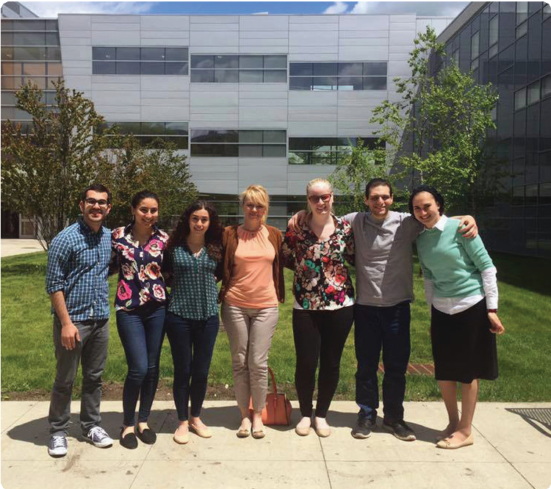
Resources and Facilities for Clinical Practice and Research
The University provides state-of-the-art facilities and resources dedicated to teaching, research,
and clinical training. These include:
- A clinical training suite with clinical practice offices, a client monitoring, observation, and recording control room, and meeting spaces. This facility supports clinical training and may serve as a clinical and research resource as well.
- A dedicated graduate teaching and testing room that is a repository for tests, assessment instruments, and media, and where students can practice testing and assessment skills.
- A graduate study suite that offers students a place of their own for studying, socializing, and fostering a supportive graduate community. The space includes computers, printers, and a projection system to provide students a place to practice their presentations for courses, conferences, and other professional endeavors.

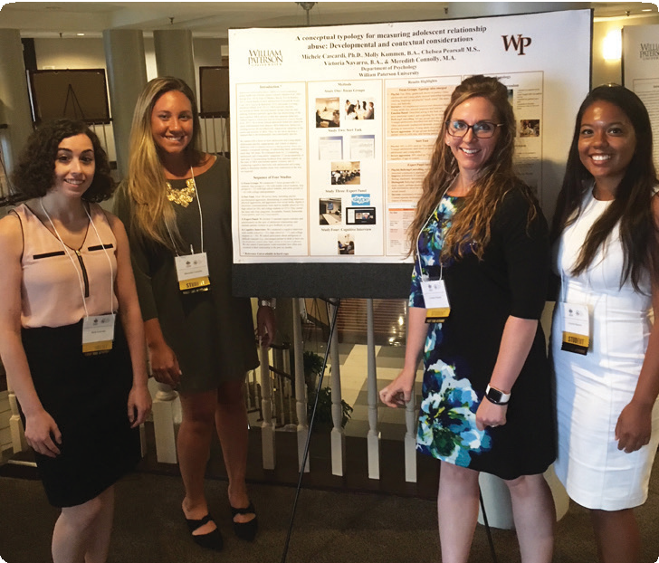
Research Laboratories
Research is conducted in a variety of labs that are organized around faculty interests, including:
  - Addictions and Substance Abuse • Applied Neuropsychology • Anxiety Disorders • Borderline Personality Disorder • Child Victimization and Maltreatment •
Chronic Disease and Disorders • Clinical Neuropsychology and Cognitive Neuroscience • Concussion • Cognition and Emotion • Community-Based Interventions • Complementary, Alternative and Integrative Medicine/Psychotherapy • Cross-Cultural Psychology • Impulsive-Aggressive Behavior • Integrating Neuroscience and Clinical Psychology • Mindfulness •
  - Minorities and Social Marginalization • Mood Disorders • Neurologic and Neuropsychiatric Disorders • Neurorehabilitation • Psychopharmacology
  - Stress Reduction • Suicidal Behavior
  - Third-Wave Behavioral Treatments • Trauma-Related Disorders • Trauma and Aggression • Forensic Psychology



Financial Support for Graduate Study
Minimum Recommended Admissions Requirements for Doctor of Psychology
- A bachelor’s degree and official transcripts from an accredited institution or an appropriately certified foreign institution.
- Grade point average of at least 3.0 (on a scale of 4.0)
- Current resume or curriculum vita.
- Personal statement.
- Three professional recommendations from professors, mentors, or supervisors.
- Prerequisite courses:
  - Abnormal Psychology
  - Statistics
  - Developmental Psychology
  - Physiological Psychology or equivalent
  - Research Methods
- Interview with members of the PsyD Admissions Committee and current PsyD students
For more information about admissions criteria visit:
www.wpunj.edu/cohss/departments/ psychology/psyd/admissions.html

Graduate Assistantships
Graduate assistantship opportunities will be available to select students with outstanding credentials. The assistantships provide tuition waivers and a stipend. Contact the Graduate Admissions Office at 973.720.3641 or the PsyD program at 973.720.3500 for details.

Teaching
Students who hold an MA/MS degree in psychology or a related field may be eligible to teach in the William Paterson University Psychology Department. Adjunct faculty receive teaching experience, financial compensation, and partial tuition remission.

Grants and Scholarships
Contact the program regarding research, clinical, or training grants that may be available for student support.

Distinguished Faculty
The professors in William Paterson University’s PsyD program have a diverse range of research and clinical interests and areas of specialization. They bring an extensive record of publications and national and international conference presentations.
Alex Bonagura, PhD. BA, The George Washington University, Washington DC; M.P.S, University of Maryland, College Park, MD; PhD, John Jay College of the City University of New York, New York, NY; Postdoctoral Resident, Behavioral Health and Justice Division of the City of Philadelphia; PA Licensed Psychologist (NY). Dr. Bonagura's research focuses on the intersection of sexuality, violence, law, and policy. Her research approach focuses on practical applications of liberatory and abolitionist feminist perspectives to criminal justice processes drawing from multiple academic traditions such as disability, queer, and gender studies. She is particularly interested in questions related to the understanding and construction of consent as a product of both legal, historical, and sociocultural factors as well as issues of stigmatization and discrimination of those with serious mental illness and developmental disabilities. Dr. Bonagura is also a practicing forensic psychologist who conducts violence risk, diversion, and level of care evaluations for justice-involved individuals.
Megan Chesin, PhD. BA, College of William and Mary, Williamsburg, VA; PhD, City University of New York, New York, NY; Postdoctoral Research Fellow, Columbia University, New York, NY; Licensed Psychologist (NY, NJ). Professor Chesin specializes in the study of impulsive-aggressive behavior and third-wave behavioral treatments, such as mindfulness-based cognitive therapy and dialectical behavior therapy. Her research interests also include minority college student mental health, executive attention, and stress response, particularly as these factors, or changes to them, relate to suicidal behavior or explain treatment gains among suicidal individuals.

Bruce J. Diamond, MEd, PhD. BA, The Ohio State University, Columbus, OH; MEd, Smith College, Northampton, MA; PhD, University of Manchester, Manchester, UK; Licensed Psychologist (NJ)
specializing in clinical neuropsychology. His areas of research include cognitive neuroscience, psychophysiology, and neurorehabilitation.
Professor Diamond is a practicing clinician whose specific research interests include memory, executive function, attention, information and language processing, and mood/anxiety in clinical and healthy populations.
William Ernst, Psy.D., BA. & M.A., The College of New Jersey, Psy.D., James Madison University. Postdoctoral Fellowship in Clinical Neuropsychology, University of Medicine and Dentistry of New Jersey/Robert Wood Johnson Medical School/Cooper Hospital. Licensed Psychologist (NJ & PA). Research interests include concussion with an emphasis on two areas: 1) peer-oriented concussion education programs designed to increase concussion disclosure to health care professionals, and 2) interventions for athletes and non-athletes with persisting concussion symptoms. Research interests also include performance validity assessment, medical decision-making capacity evaluations, and neuropsychological consultation with school personnel. Dr. Ernst is a practicing psychologist specializing in clinical neuropsychology.

Aileen Torres, PhD. BA, Boston University, Boston, MA; MA, Columbia University, New York, NY; PhD, Carlos Albizu University, San Juan, Puerto Rico; Licensed Psychologist (NJ). Professor Torres specializes in child abuse, trauma, family therapy, and bicultural parenting issues. She is a mentor for the American Psychological Association’s Minority Fellowship Program, Training Advisory Committee and a Past-President of the Latino/a Psychological Association of NJ. Her research focuses on childhood sexual abuse, parenting, mental health disparities in low-income minority communities, cultural identity development, and immigration-related
psychological evaluations. She is endorsed as a Level IV Clinical Mentor by the NJ Association for Infant Mental Health.






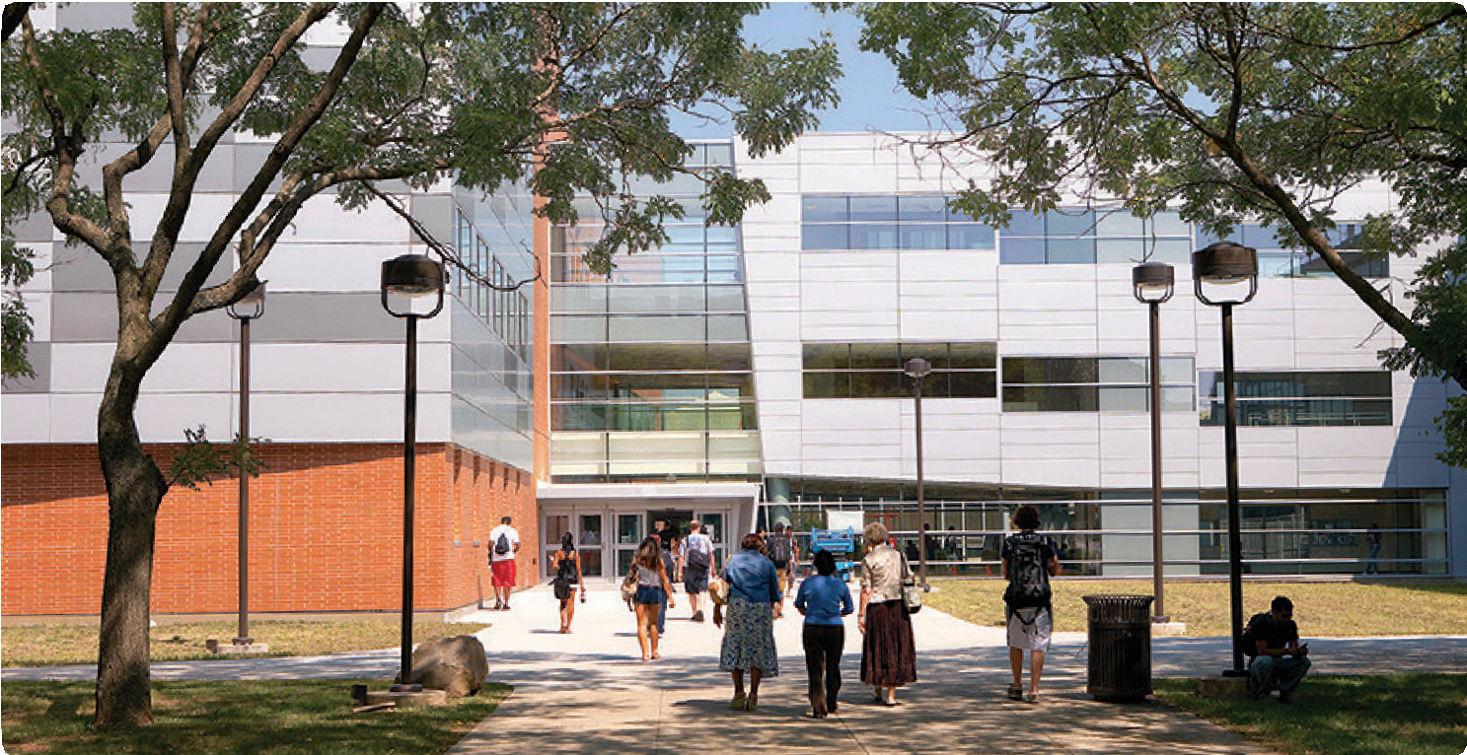

Located on 370 wooded acres in suburban Wayne, New Jersey, William Paterson University is composed of four academic colleges: Cotsakos College of Business, College of Education, College of Arts, Humanities and Social Sciences, and College of Science and Health. In addition to its graduate programs, the University offers a wide range of undergraduate programs, as well as a number of programs leading to endorsement for teacher certification and other professional licensing qualifications.
When you choose graduate study at William Paterson University, you will benefit from small classes; numerous research, internship, and clinical experiences; and sophisticated educational resources. You will receive individualized attention from faculty who provide a valuable blend of accomplished scholarship and practical, applied experience. Among the University’s faculty are 41 Fulbright scholars and recipients of many other awards, grants, and fellowships.
For more information, contact the Office of Graduate Admissions and Enrollment Services at 973.720.3641, visit wpunj.edu/graduate or email graduate@wpunj.edu. For more information about the PsyD program, visit wpunj.edu/psyd.

wpunj.edu/graduate

